St10358665

**Travel Packages**: Users can explore and book a range of travel packages tailored to different preferences and budgets.

**Destination Guides**: The site provides detailed guides on various destinations, helping users make informed decisions about where to travel.

**Booking Services**: It facilitates booking flights, accommodations, and other travel-related services, streamlining the planning process.

**Travel Tips and Advice**: The platform may offer tips and advice for travelers, enhancing their overall experience.

**1.2**

**Usability Goals Implementation**

**1. Easy to Learn**

The website will feature a user-friendly interface with clear navigation and labeling. This includes:

**Intuitive Layout**: Organizing content in a logical manner to help users quickly find what they need.

**Onboarding Guides**: Providing tutorials or tooltips for first-time visitors to familiarize them with key functionalities.

2. Efficient to Use

**Streamlined Navigation**: Implementing a simple menu structure that allows users to access important sections quickly.

**Search Functionality:** Including a robust search bar to enable users to find specific travel packages or information without hassle.

**3. Effective to Use**

**Feedback Mechanisms**: Allowing users to report issues easily, which will help in making iterative improvements.

**4. Safe to Use**

**Error Handling**: Providing clear error messages and guidance on how to resolve issues, enhancing user confidence.

**5. Good Utility**

**Comprehensive Resources**: Offering destination guides and travel tips that cater to user interests.

**6. Memorable**

**Visual Appeal**: Incorporating high-quality images and engaging content that resonates with users and encourages return visits.

1.3

Desirable Aspects of User Experience

**1. Aesthetic Appeal**

The website will feature a visually appealing design with high-quality images and a cohesive color palette that reflects the travel theme. This aesthetic will engage users and create a positive first impression.

**2. Intuitive Navigation**

Clear and straightforward navigation will be prioritized, allowing users to find information quickly. This includes well-organized menus and breadcrumb trails that help users understand their location within the site.

**3. User Feedback Integration**

Encouraging user feedback through surveys or ratings will help continuously improve the site. Implementing changes based on this feedback demonstrates responsiveness to user needs.

1.4

**Design Principles**

1. **Consistency**

Maintaining a consistent design across all pages will help users familiarize themselves with the interface. This includes uniform use of colors, fonts, and layout styles to create a cohesive look and feel throughout the site.

**2. Simplicity**

The design will prioritize simplicity by eliminating unnecessary elements that could distract users. A clean layout with straight forward navigation will make it easier for users to focus on their travel options without feeling overwhelmed.

**3. Visual Hierarchy**

Establishing a clear visual hierarchy will guide users' attention to the most important information first. This can be achieved through the strategic use of size, color, and placement of elements such as headings, images, and buttons.

**1.4**

**Interaction Types**

**1. Click Interactions**

Users will engage with the website primarily through click interactions, allowing them to navigate between pages, select travel packages, and access detailed information about destinations and services.

**2. Search Interactions**

A search bar will enable users to quickly find specific travel options or information by entering keywords. This interaction type will streamline the user experience by reducing the time spent navigating through menus.

**3. Social Media Sharing**

Integration of social media sharing buttons will allow users to share their favorite travel packages or articles directly on their social networks, enhancing user engagement and promoting the website.

**1.5**

**Social Interactions**

**1. Social Media Integration**

The website will include links to various social media platforms (e.g., Facebook, Instagram, Twitter) where users can follow the brand for updates, travel inspiration, and promotions. This integration encourages users to engage with the brand outside the website.

**2. User Reviews and Testimonials**

Incorporating a section for user reviews and testimonials will allow travelers to share their experiences with others. This not only builds trust but also fosters a sense of community among users.

**3. Social Contests and Promotions**

Running social media contests or promotions can incentivize users to engage with the brand online, such as sharing photos from their travels or participating in giveaways related to travel packages.

**Emotional Interaction Strategies**

**1. Storytelling**

The website will utilize storytelling techniques in its content to evoke emotions. This can include sharing personal travel stories, experiences from satisfied customers, and engaging narratives about destinations that inspire users to dream about their own travels.

**2. Personalization**

By offering personalized recommendations based on user preferences and past interactions, the website can create a tailored experience that resonates emotionally with users. This approach makes users feel valued and understood.

**3. Community Building**

Creating a sense of community through user-generated content, such as travel blogs or photo galleries, allows users to connect with others who share similar interests. This fosters emotional ties and encourages users to engage more deeply with the brand.

**6. Feedback and Support**

Providing responsive customer support and actively seeking user feedback can create a sense of trust and care. When users feel supported, it enhances their emotional connection to the brand.

1.7 Web Content Accessibility Guidelines (WCAG) 2.0

**1. Perceivable**

**Text Alternatives**: All non-text content, such as images and videos, will have descriptive alt text to provide context for users who rely on screen readers.

**Audio and Video**: Multimedia content will include captions and transcripts to make information accessible to users with hearing impairments.

**Adaptable Content**: The website will be designed to allow users to customize the display, such as adjusting font sizes and colors for better readability.

**2. Operable**

**Keyboard Navigation:** The site will be fully navigable using a keyboard, ensuring that users who cannot use a mouse can still access all features.

**Clear Navigation:** Consistent and clear navigation mechanisms will be implemented, including visible focus indicators for interactive elements.

**3. Understandable**

**Readable Text:** Content will be written in plain language, avoiding jargon where possible, to ensure comprehension by a wide audience.

**Consistent Layout:** The layout and navigation will remain consistent across all pages, helping users predict where they can find information.

**Error Identification:** When users encounter errors in forms or interactions, clear instructions will be provided to help them correct mistakes.

Part 2

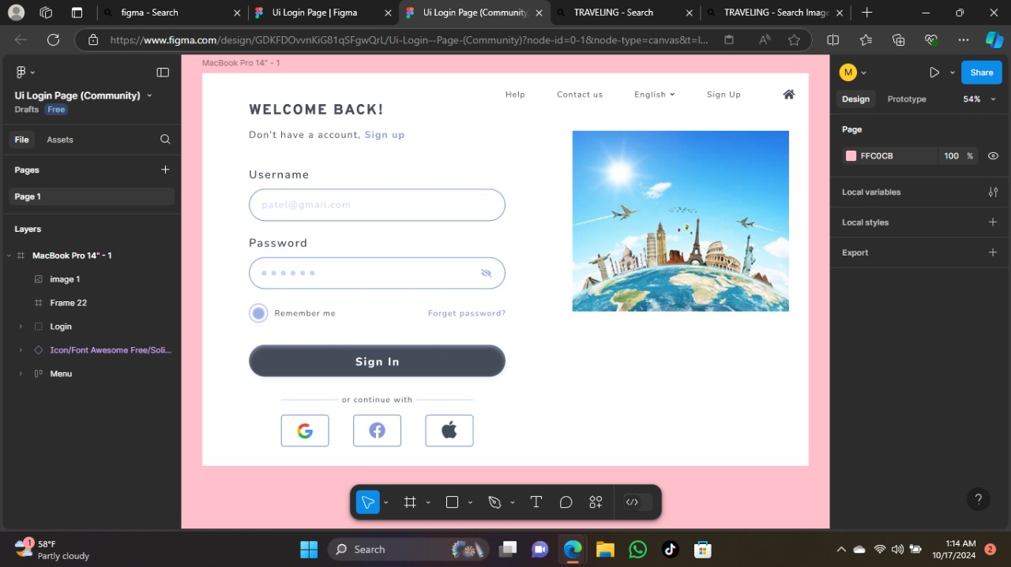

This is the sign up page which will prompt the user to sign up if they don’t have an account yet

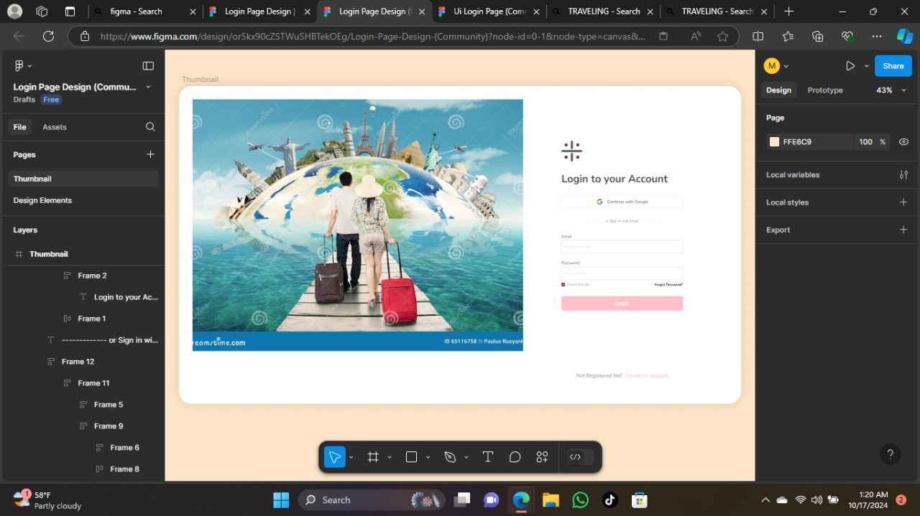

Then after signing up is then that the user will log in so that they can start looking and the packages.

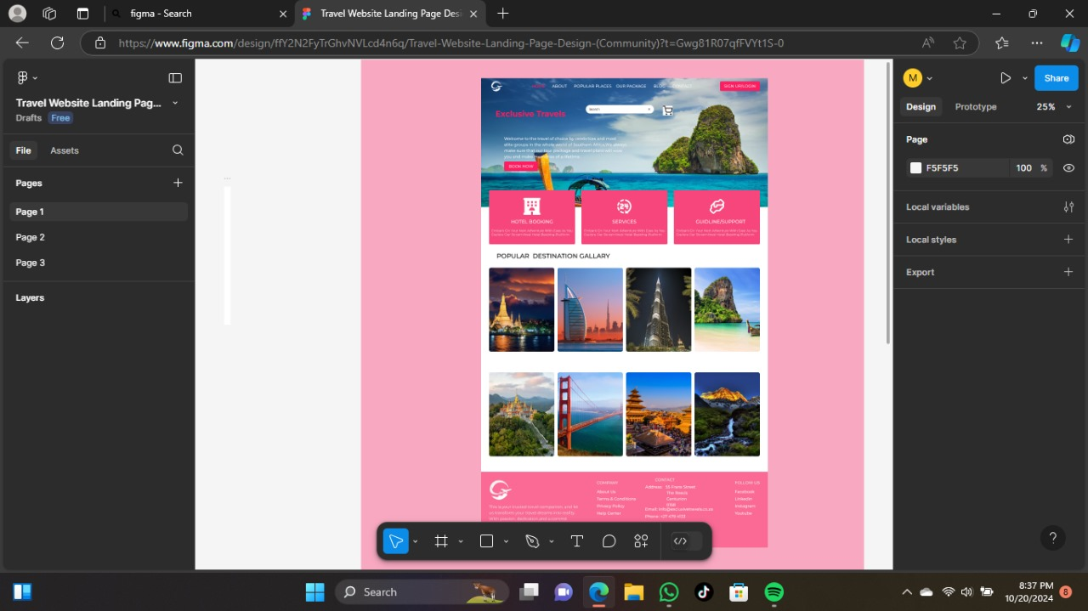

This is the home page which it shows the gallery of some of the places they can choose from so they can have nice experience with exclusive travels.It is also user friendly the search bar is not hidden so that the user can search whatever they want to search.It is also colorfull and attractive and eye catchy.

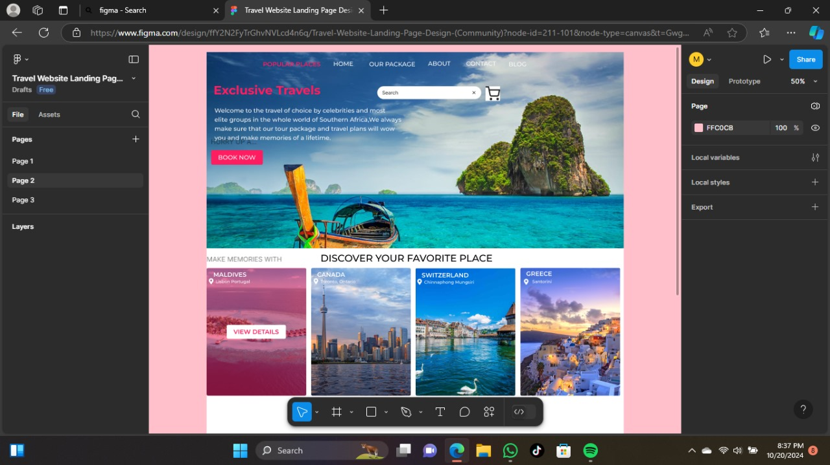

This is also a page where if the user have never traveled before they get to check out some of the places which has been visited already.

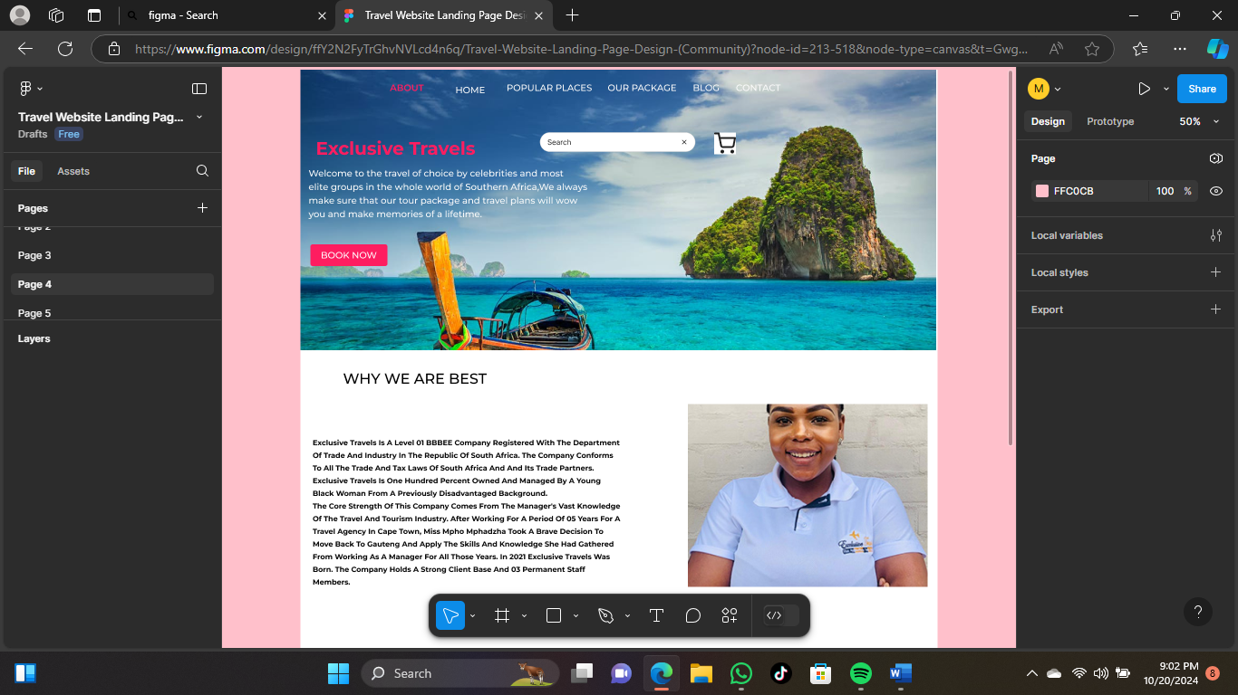

This is the about page where the user get to read more about the company’s background.

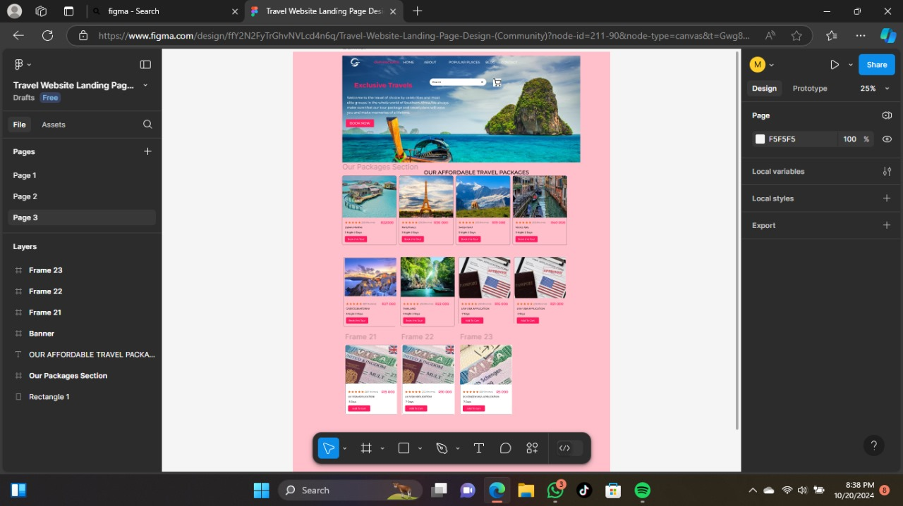

So this is the package page where the user get to see the prices of the trips and the visas .It helps them to choose exactly what they want as well as the price of the thing the want .

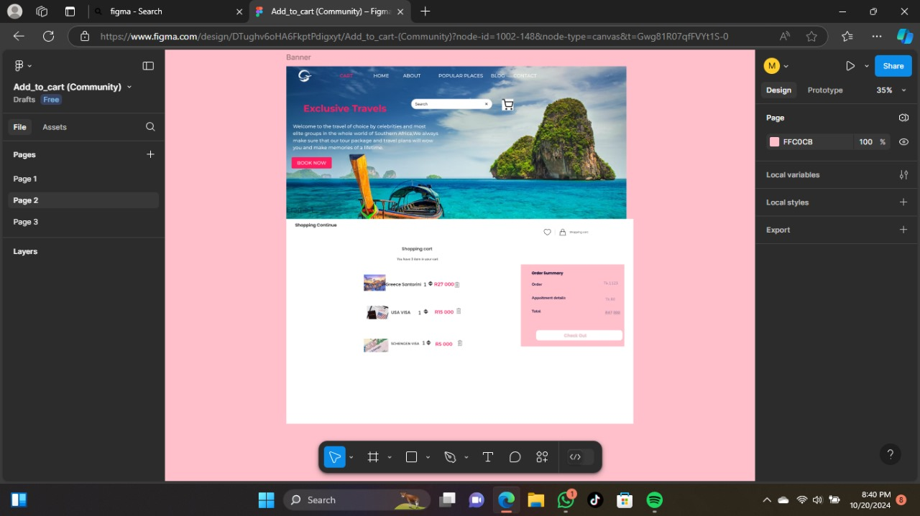

After choosing the package of they’re choice they will add it to the cart which will be preparing them for checkout.

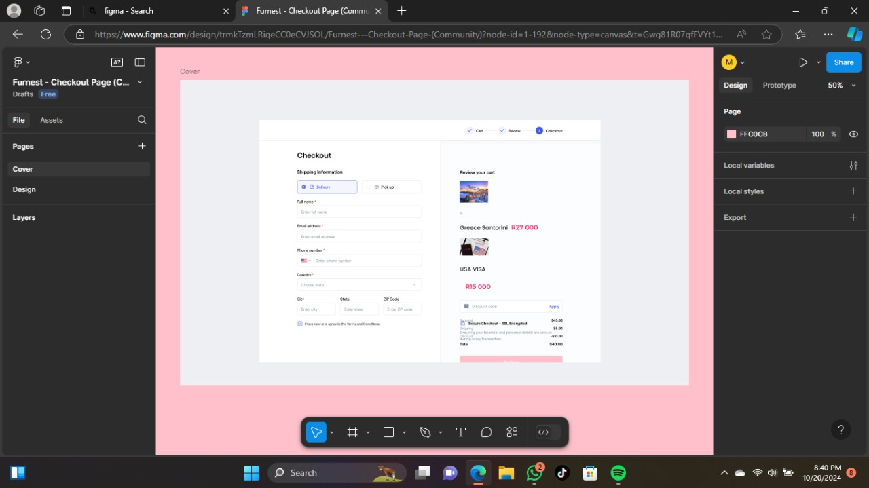

And this is the checkout page which the user pays for the package the choose to confirm they’re booking for the drip or the visa so that they cant start processing they’re order.

**Citations:**

**https://www.figma.com/proto/ffY2N2FyTrGhvNVLcd4n6q/Travel-Website-Landing-Page-Design-(Community)?node-id=213-518&t=Gwg81R07qfFVYt1S-1**

[1] https://exclusivetravels.co.za

https://www.figma.com/proto/trmkTzmLRiqeCC0eCVJSOL/Furnest---Checkout-Page-(Community)?node-id=1-192&t=Gwg81R07qfFVYt1S-1